**SceernShots of Application**

**Home Page :**

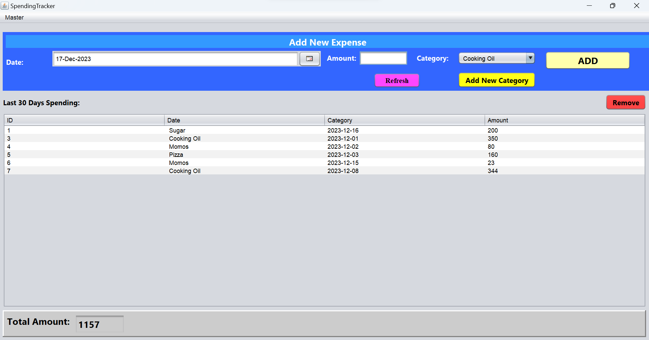

**Menu Bar:**

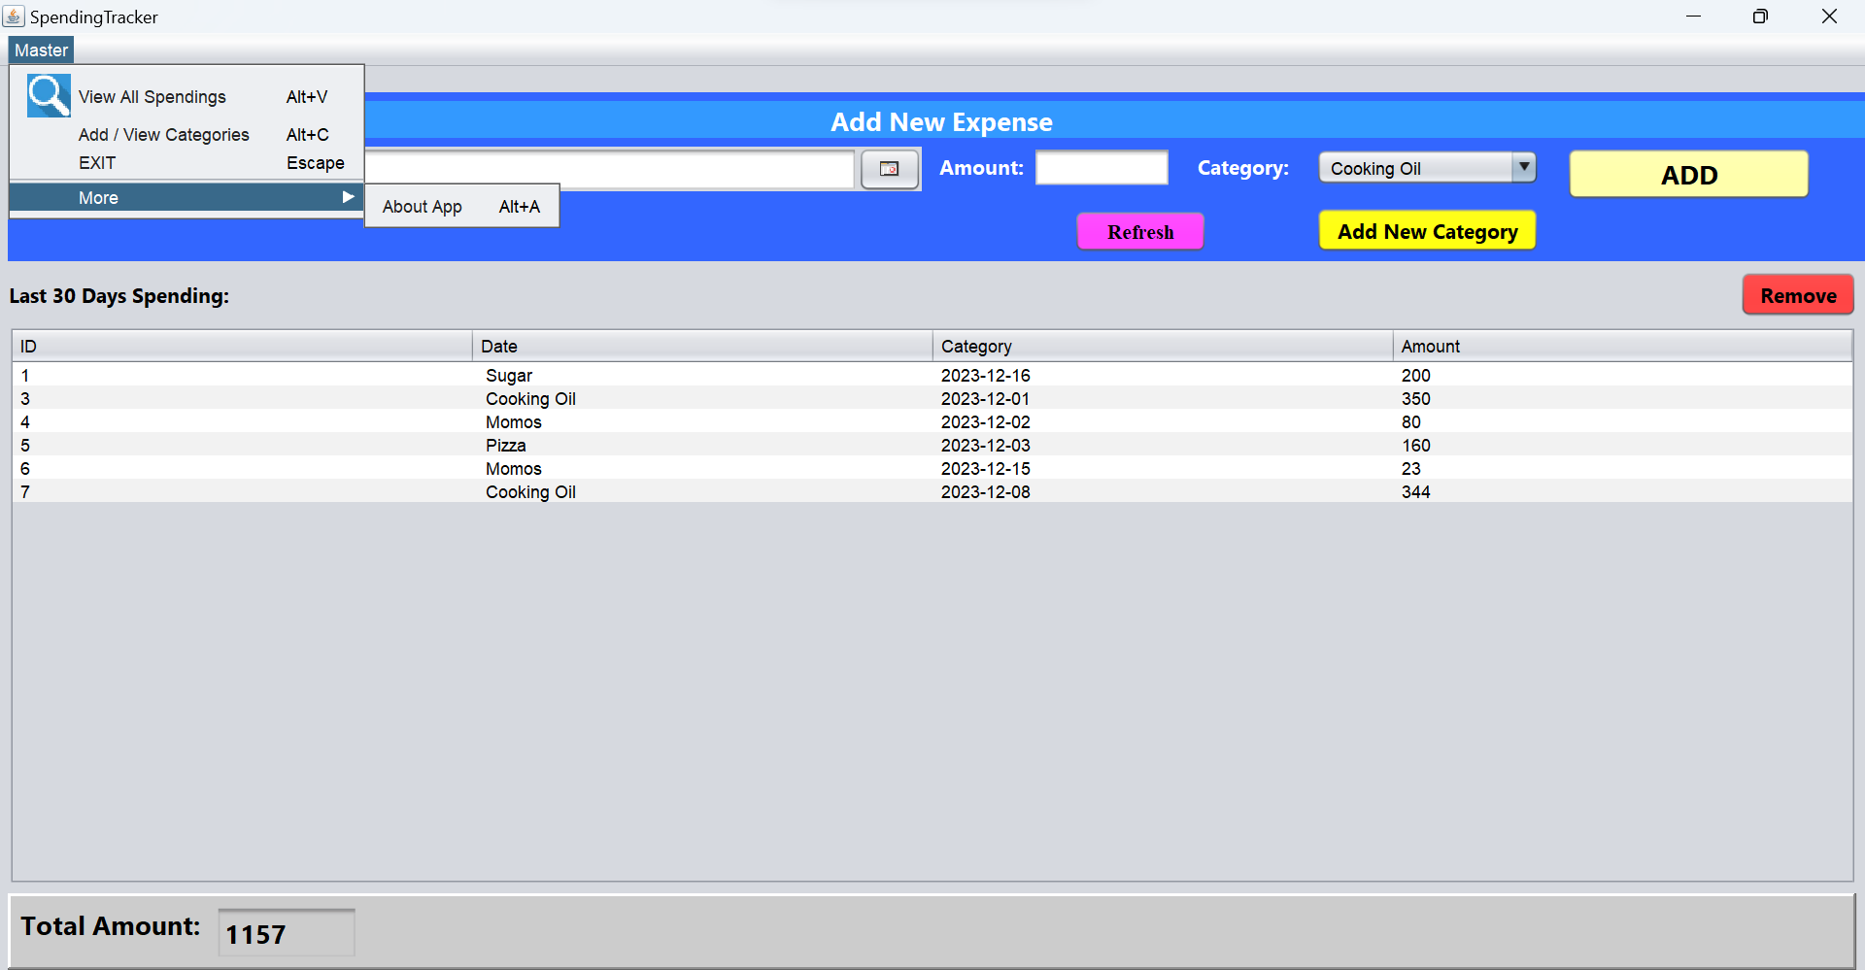

**Add new Category :**

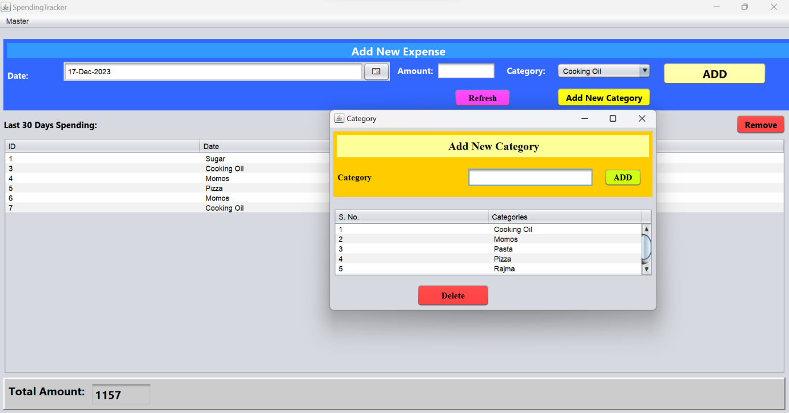

**To See All the Spendings :**

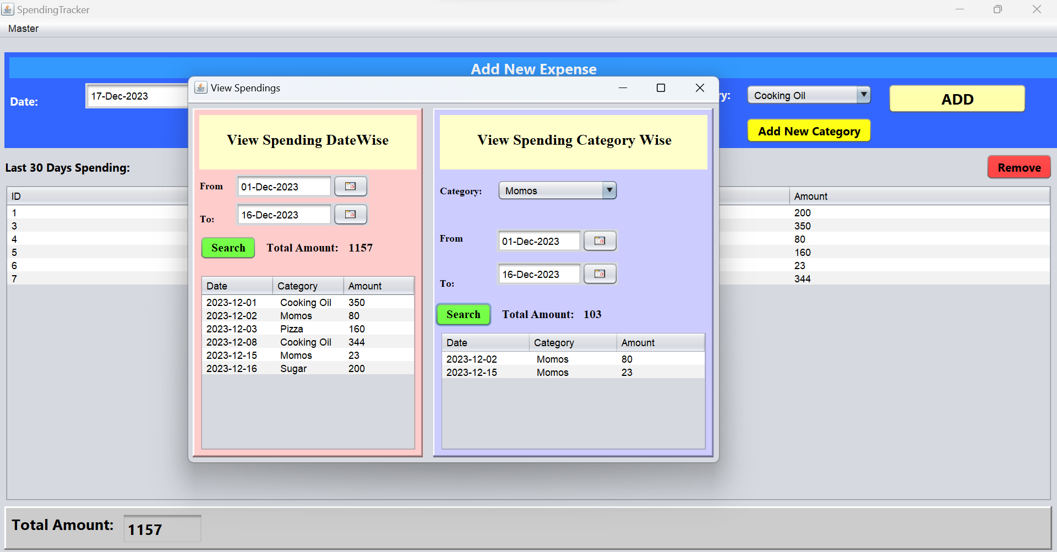

**LINK TO APPLICATION :**

https://drive.google.com/drive/folders/1ayOJbUFcwth8Dfwb6rgOhNdNIbz0UOHW?usp=drive_link